1. The Fundamentals of Motion
Motion is a relative concept. An object is considered to be in motion if its position changes with respect to its surroundings; otherwise, it is at rest.
- Distance: The actual length of the path traveled by an object.
- Displacement: The minimum distance (straight line) between the starting and finishing points.
Note: Displacement can be zero if you return to your starting point, but the distance traveled will always be a positive value.
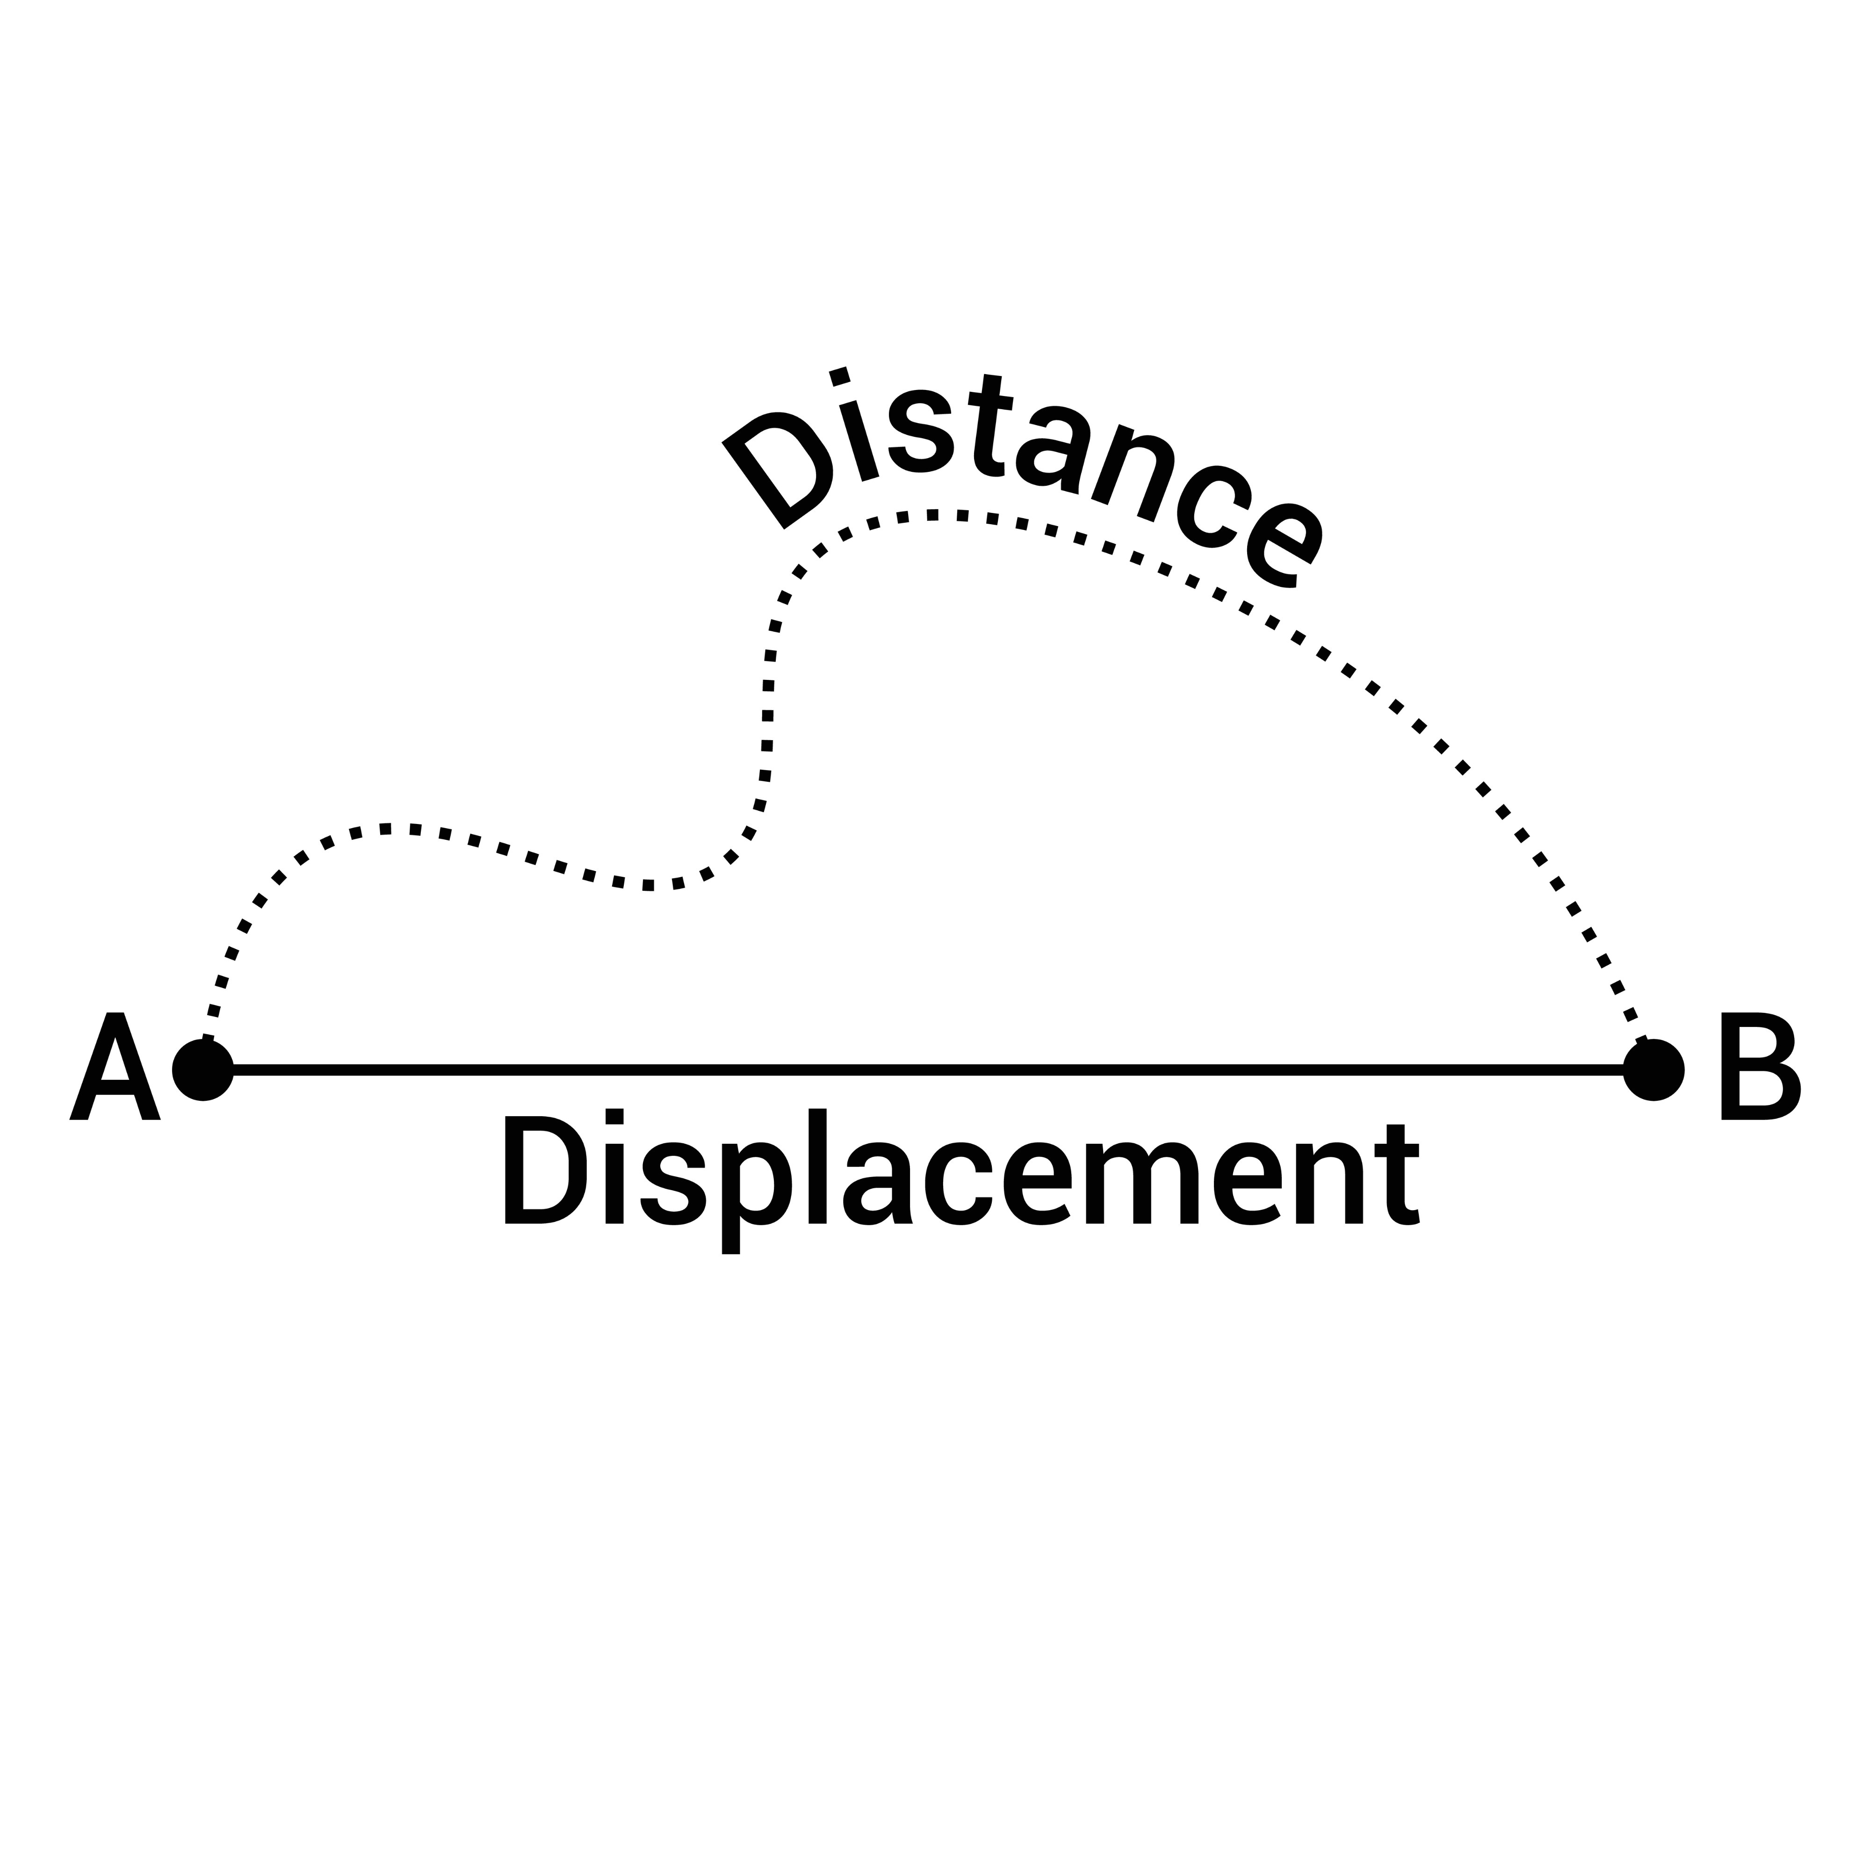
2. Speed and Velocity
These terms describe how fast an object moves, but they differ in directionality.
Feature | Speed | Velocity
Definition | Total distance divided by time | Displacement per unit time
Formula | $Speed = \frac{\text{Distance}}{\text{Time}}$ | $Velocity = \frac{\text{Displacement}}{\text{Time}}$
Quantity Type | Scalar (Magnitude only) | Vector (Magnitude + Direction)
SI Unit | m/s | m/s
Factors affecting Velocity: Velocity changes if you change the speed, the direction of motion, or both.
3. Acceleration
Acceleration is defined as the rate of change of velocity.
- Formula: $a = \frac{v - u}{t}$ (where $v$ = final velocity, $u$ = initial velocity, $t$ = time).
- Positive Acceleration: Velocity increases over time.
- Negative Acceleration (Deceleration/Retardation): Velocity decreases; the force acts opposite to motion.
- Zero Acceleration: Velocity remains constant.
4. Newton’s Equations of Motion
Newton provided three fundamental equations for objects moving in a straight line with uniform acceleration:
- Velocity-Time Relation: $v = u + at$
- Displacement-Time Relation: $s = ut + \frac{1}{2}at^2$
- Displacement-Velocity Relation: $v^2 = u^2 + 2as$
5. Uniform Circular Motion
When an object moves at a constant speed along a circular path, it is in Uniform Circular Motion.
- Changing Velocity: Even if speed is constant, velocity is always changing because the direction changes at every point.
- Direction: The velocity at any point is always tangent to the circular path.
- Calculation: $v = \frac{2\pi r}{t}$
6. Newton’s Three Laws of Motion
First Law: Law of Inertia
An object remains at rest or in uniform motion unless acted upon by an external unbalanced force. Inertia is the inherent resistance of an object to change its state.
Second Law: Force and Momentum
The rate of change of momentum is proportional to the applied force.
- Momentum ($P$): $P = mv$ (Mass × Velocity).
- Force Formula: $F = m \times a$
- Units: SI unit is Newton (N); CGS unit is dyne ($1 N = 10^5 dynes$).
Third Law: Action and Reaction
For every action, there is an equal and opposite reaction acting simultaneously.
- These forces act on different objects, so they do not cancel each other out.
7. Law of Conservation of Momentum
If no external force acts on two interacting objects, their total momentum remains constant.
- Collision Formula: $m_1u_1 + m_2u_2 = m_1v_1 + m_2v_2$
- Recoil Example: When a gun fires a bullet, the gun moves backward (recoils). The total momentum before and after the shot remains zero because the forward momentum of the bullet is balanced by the backward momentum of the gun.
